Upgrading Your Oracle9i Database to Oracle Database 10g

Purpose
In this lesson, you learn how to upgrade your Oracle9i Database to Oracle Database 10g with the Database Upgrade Assistant.

Topics
This lesson covers the following topics:
Overview
Prerequisites
Verifying the SYSTEM Tablespace
Upgrading Your Database with the Database Upgrade Assistant

Viewing Screenshots
Place the cursor on this icon to display all the screenshots in the lesson. You can also place the cursor on each individual icon in the following steps to see only the screenshot that is associated with that step.

Overview
Back to List
Using the Database Upgrade Assistant, you will upgrade your Oracle9i Database to Oracle Database 10g.

Prerequisites
Back to Topic List
Before starting this lesson, you should have:
1. | Completed the Configuring Linux for the Installation of Oracle Database 10g lesson
2. | Completed the Installing Oracle Database 10g on Linux lesson
3. | Completed the Installing Oracle9i Database, Release 2 on Linux lesson  (or have access to an Oracle9i Database)

Verifying the SYSTEM Tablespace
Back to Topic List
Before you upgrade, you want to check to make sure that you have enough space in your SYSTEM tablespace. Perform the following steps:
1. | Open your browser and enter the following URL:  http://<hostname>:5500/em  Log in as sys/<password> as sysdba and click Login.
2. | Click the Administration tab.
3. | Under Storage, click the Tablespaces link  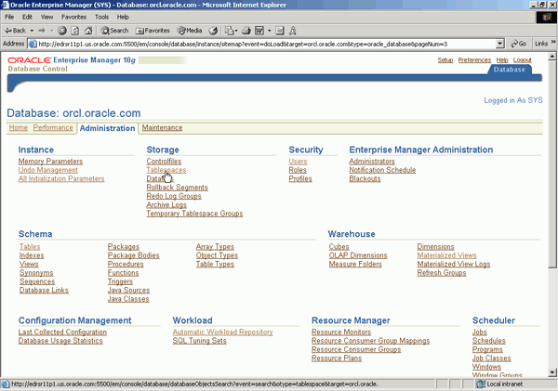
4. | Click the SYSTEM tablespace.  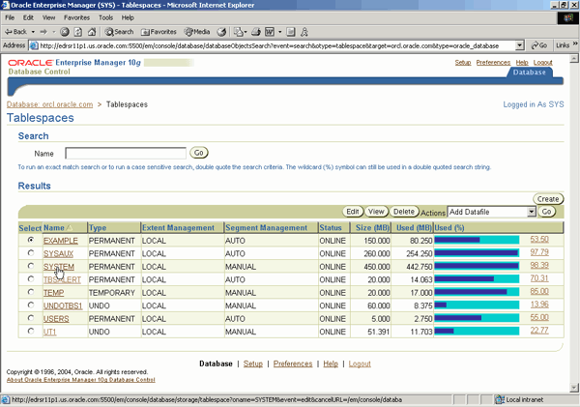
5. | In the Datafiles section, click Add.  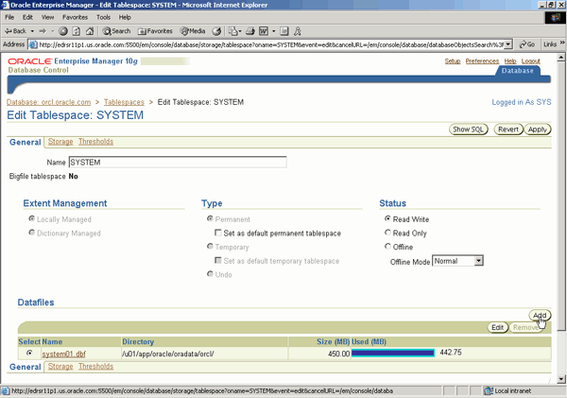
6. | Enter system02.dbf for the file name, select the Automatically extend datafile when full (AUTOEXTEND) check box, and enter 10 KB as the increment. Then click Continue.  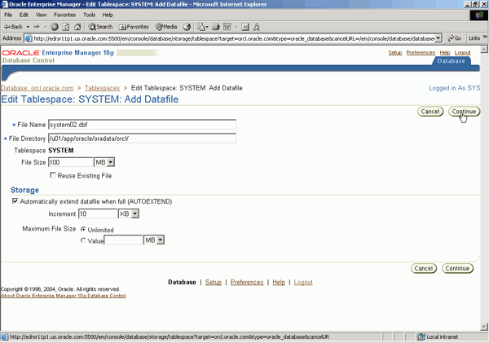
7. | Click Apply.  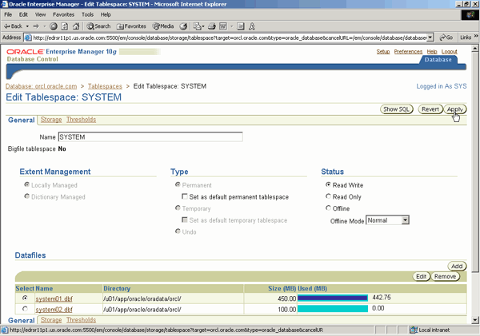
8. | Your SYSTEM tablespace now has more space in it for your upgrade.  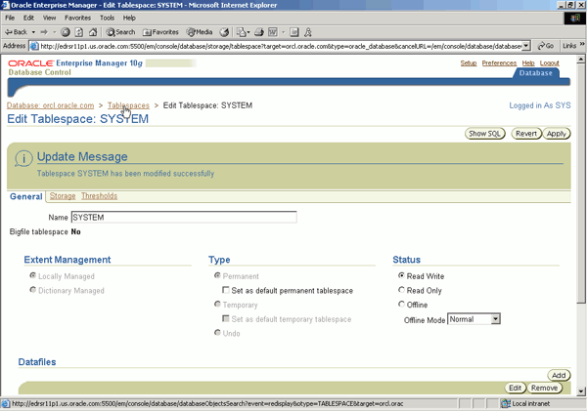

Upgrading Your Database with the Database Upgrade Assistant
Back to Topic List
To use the GUI installer to install the Oracle software, perform the following steps:
1. | Open a terminal window and execute the following commands:  cd $ORACLE_BASE/product/10.1.0/db_1/bin  dbua
2. | At the Welcome window, click Next.  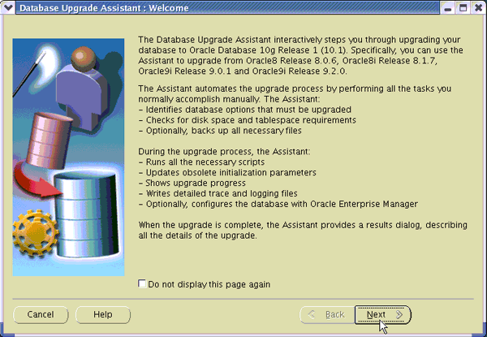
3. | Select your Oracle9i Database from the list, and then click Next.  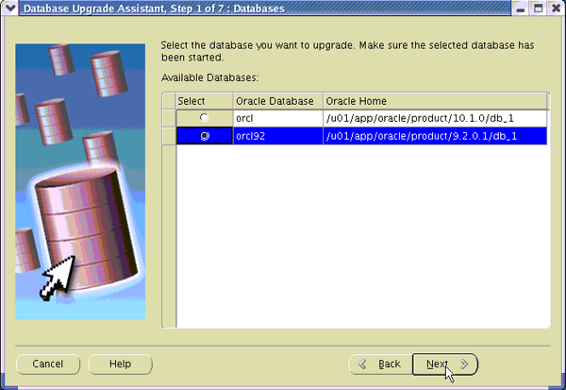
4. | You may see a screen asking you if you want to automatically extend the SYSTEM tablespace. Click Continue.  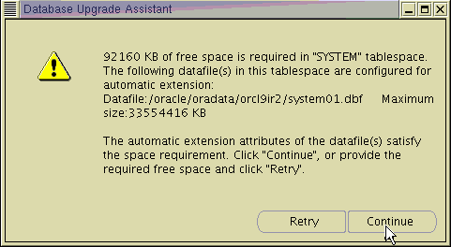
5. | You need to create a SYSAUX tablespace. Accept the default and click Next.  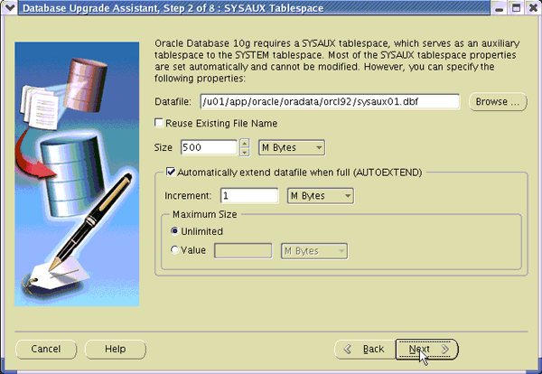
6. | You want to recompile invalid objects at the end of the upgrade. Accept the default and click Next.  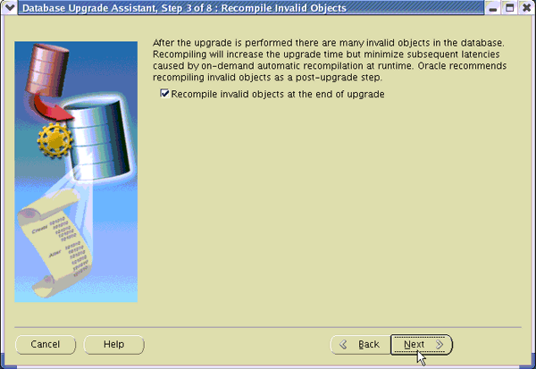
7. | You will not make a backup of your Oracle9i Database during the upgrade process. Click Next.  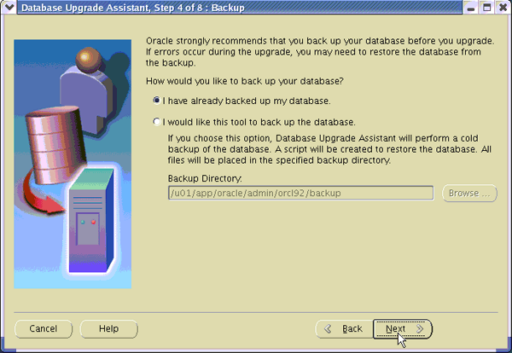
8. | Select Use Database Control for Database Management, and then click Next.  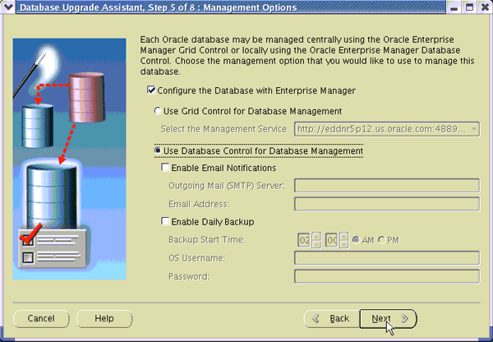
9. | Enter and confirm a password, and then click Next.  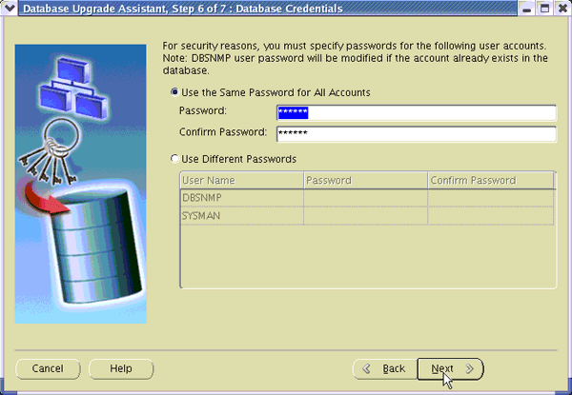
10. | Review the summary information. Then click Finish.  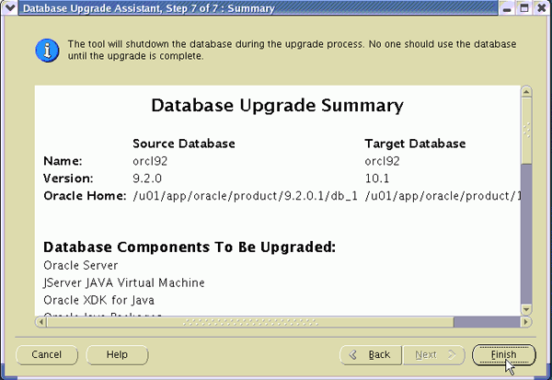
9. | You see the progress window.  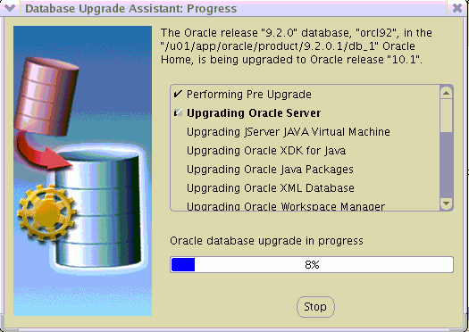
10. | When your upgrade is complete, click OK.  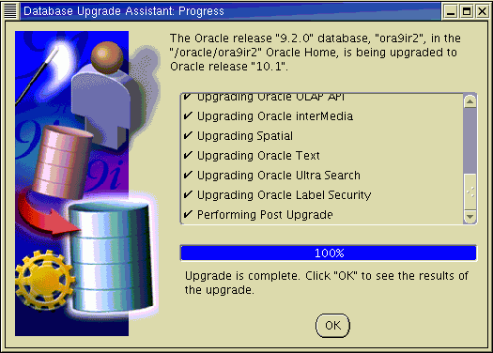
11. | You see the summary of the upgrade. Scroll down to see the output. When done, click Close.  